Chapter 6 Lab

Nabeel Hussain

Screenshotseel Hussain

**Task #4**

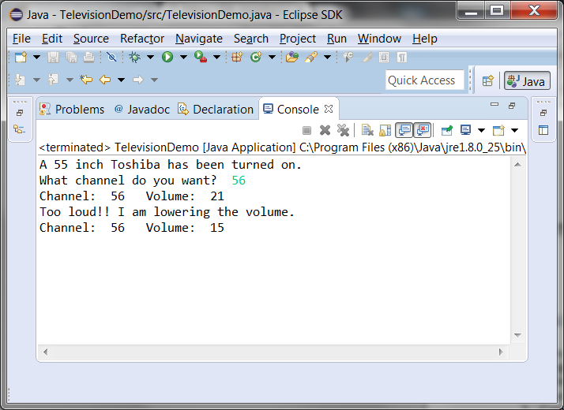**­**

**Task #5**

